Kyocera Printer General Instruction

# Installing Kyocera Printer on Your Computer (Windows)

* Download the Kyocera Windows Driver (<https://d1tp8ebtn1p0b6.cloudfront.net/documents.html)>
* Make sure you are connected to WL-Global-Office-2.4G (or 5G) Wi-Fi network
* Unzip the file
* Open ‘en’ folder
* Double click ‘Setup.exe’ application
* Follow instruction to finish the driver installation
* Double check if the printer’s IP Address is at 192.168.1.199

# Installing Kyocera Printer on Your Computer (MacOS)

* Download the Kyocera MacOS Driver (<https://d1tp8ebtn1p0b6.cloudfront.net/documents.html)>
* Make sure you are connected to the WL-Global-Office-2.4G (5G) Wi-Fi network
* Follow the instruction to finish the driver installation
* Open ‘System Preference’ 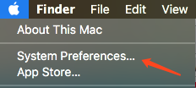
* Open ‘Printers & Scanners’ 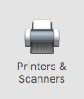
* Click ‘+’ to add a new printer 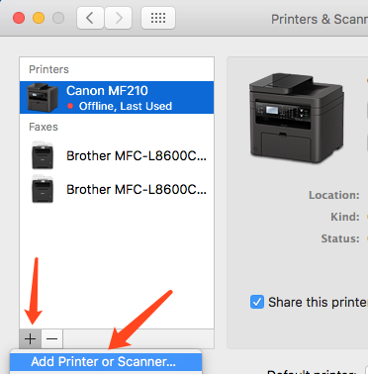
* Click ‘IP’ 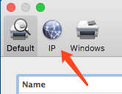
* Enter 192.168.1.199 at ‘Address’ Choose ‘HP Jetdirect – Socket’ at ‘protocol’ 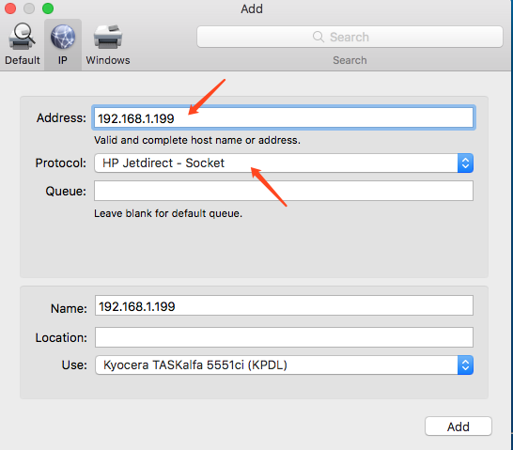
* Change ‘Name’ to anything you like
* Click ‘Add’ to add the printer in your computer to use.